Health map

Project Charter:

Project name: Health map.

Project sponsor: Ministry of Health, Ministry of communications.

Project manager: Ardina Asad.

Project team: Arwa Sayed Ibrahim, Arwa Mohamed Hamdy , Esraa Ahmed Abd Alghafoor.

project purpose:

* make it easy for the people to find the places of the medical help Whether if it is a hospital, clinic, or pharmacy, specify the Doctor's specialty and the cost of a ticket and determining the distance between the patient and the health care place and the time of arrival.

Business Case:

* We are programing this app to help people who arrives to a new town or country and doesn’t know where is the places of the medical help.

Project Results:

* health service location.
* book an appointment at a clinic and knew the cost of booking.
* collect information about doctors like specialty.

Basic milestone timeline:

* October: start collecting the required data and build a database.
* January: writing the app code and connect the code to the database.
* April: test the app.
* July: Proof the intellectual property of the program and lunch it.
* October: collect feed backs from users and make updates.

Project Resources:

* Budget: $50,000.
* Test lab reserved for two-month.
* Server.

Project Constraints, Assumptions, and Risks:

* The project must be completed by April 15.
* The project must not exceed $70,000.
* Our preferred vendors should be able to deliver our new workstations and.  
  servers on time without affecting the project schedule.
* The project must include periodic updates.
* The project must include a bake up version from the database in case of any damage.
* The project must include multiple language.

Project Scope:

scope description:

* A non-profit charitable application.
* it is easily used by all age groups.
* once the access to the app is done you will automatically get the places where you can get the medical help.
* It’s safe to use & won’t leak information about your location.

acceptance criteria:

* The user interface is easy to use.
* The outputs of the application should be retrieved so fast to the user.
* The output information must be very accurate and matching the truth.
* The application should be light and doesn't take a large amount of space.

Deliverables:

* health service location.
* book an appointment at a clinic and knew the cost of booking.
* know information about doctors like specialty.

Exclusion:

* payment by application.
* Transportation to medical services locations.
* the application limits are within the user's city not in the neighboring cities.

Constraints:

* Budget: $50,000.
* Time: 12 months.
* Resources: Test lab reserved for two-month.

Assumptions:

* All the doctors would approve to register to our application.
* Cost accuracy.

Project WBS:

1. Planning:

* Create the goals
* specify project requirements.
* make a work plan.

2.The Cost:

* make a feasibility study & budget
* Buying the requirements.

3.Execution:

* writing codes
* make design and logo.
* Create a property intellectual document.

4. Project launch:

* Test the Project.
* Launch the project.
* Follow up on user feedback.

WBS Dictionary:

Creating the goals:

* Code: A11.
* Description: specify our project goals and its initial ideas such as outputs of the app & why we created the app.
* The responsibility of the element: Project manager, project assistant & sponsor.
* Scheduled creation: 15 days.
* The cost: 3000$.
* criteria of acceptance: fits societal standers, useful and provide a unique serves.

specify requirements:

* Code: A12.
* Description: Requirements that will assist in the implementation of the project will be identified whether these are human, material or financial.
* The responsibility of the element: Project manager, project assistant, sponsor, finance team and legal affairs.
* Scheduled creation: 15 days.
* The cost: 3000$.
* criteria of acceptance: good quality equipment suitable for the project and affordable.

Work plan:

* Code: A13.
* Description: An action plan is created that saves time, identifies tasks, and the time needed to perform tasks.
* The responsibility of the element: Project Manager, Manager assistants, Sponsor & marketing team.
* Scheduled creation: 15 days.
* The cost: 3000$.
* criteria of acceptance: Plan identifies the task to the right person, saves time, effort, and the same time that delivers the project on schedule.

feasibility study & budget:

* Code: A14.
* Description: budget is important to the realization of the project, The budget required to achieve the project and will be determined based on the requirements and the capital available.
* The responsibility of the element: Project Manager, Manager assistants, Sponsor& finance team.
* Scheduled creation: 15 days.
* The cost: 3000$.
* criteria of acceptance: It must be adequate to meet requirements and not prohibitive or substandard on the ground.

buying requirements:

* Code: A15.
* Description: In this phase the necessary equipment to complete the work will be assembled based on the project requirements and budget available.
* The responsibility of the element: Project manager, sponsor, finance team and marketing team.
* Scheduled creation: 1 month.
* The cost: 15000$.
* criteria of acceptance: Budget should be sufficient to collect requirements without requiring funds for increases or decreases in requirements.

Responsibilities Matrix:

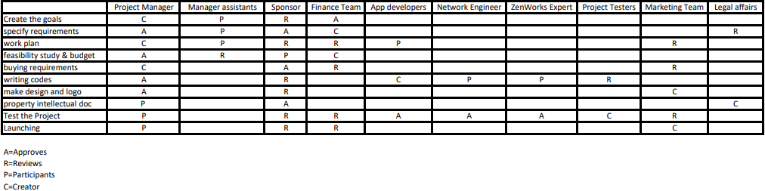

Project network:

|  |  |  |  |
| --- | --- | --- | --- |
| **Aoutomated warehaouse**  **Order picking system** | | | |
| Activity | description | Preceding activity | duration |
| A11 | Creating goals | None | 2 |
| A12 | Specify requirement | None | 2 |
| A13 | Work plan | A12, A11 | 2 |
| A14 | Feasibility study & budget | A12 | 2 |
| A15 | Buying requirement | A14 | 4 |
| B1 | Writing code | A15, A13 | 16 |
| C1 | Make design & logo | A15, A13 | 4 |
| D1 | Property intellectual document | C1, B1 | 4 |
| E1 | Test the project | D1 | 8 |
| F1 | Launching | E1 | 4 |

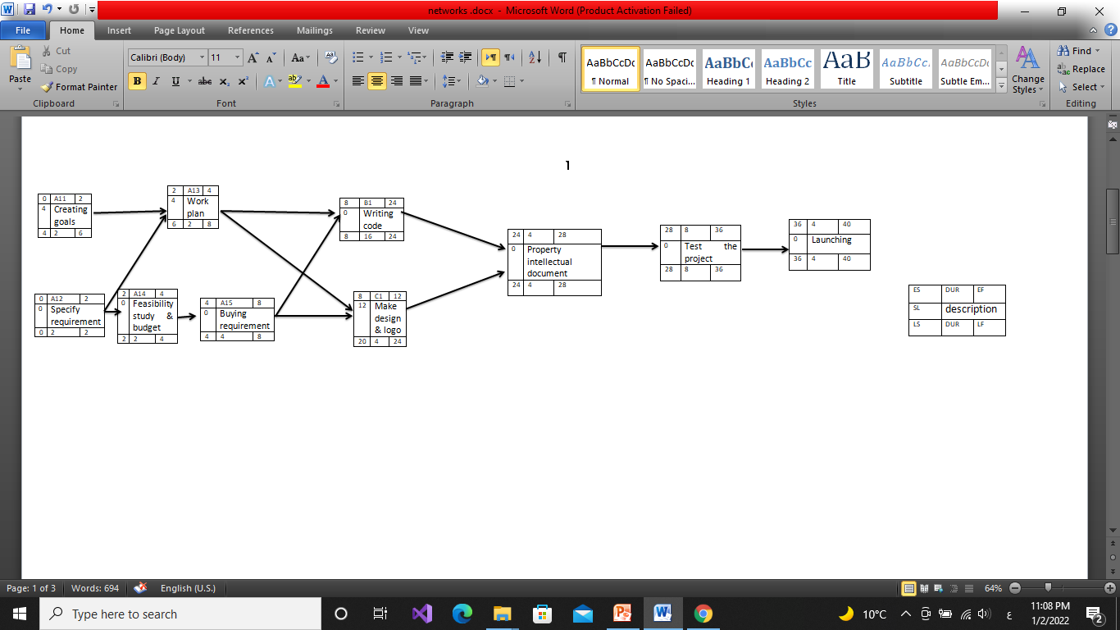

RESOURCE CONSTRAINED PROJECT:

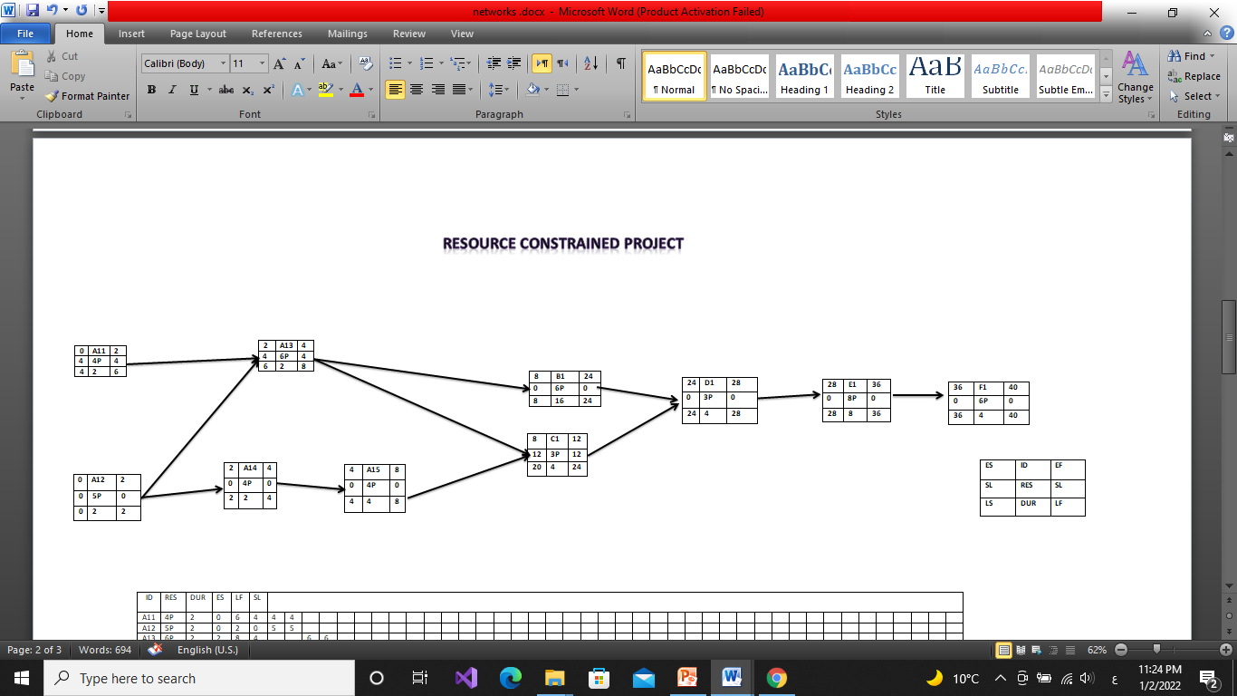

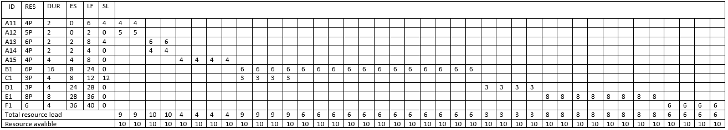

TIME-PHASED BUDGET BASELINE:

•Matrix of Activity with weekly cost:

|  |  |  |  |  |  |  |  |  |  |  |  |  |  |  |  |  |
| --- | --- | --- | --- | --- | --- | --- | --- | --- | --- | --- | --- | --- | --- | --- | --- | --- |
| Activity |  |  |  |  |  |  |  |  |  |  |  |  |  |  |  |  |
| A11 | 1500$ | 1500$ |  |  |  |  |  |  |  |  |  |  |  |  |  |  |
| A12 | 1500**$** | 1500$ |  |  |  |  |  |  |  |  |  |  |  |  |  |  |
| A13 | 1500$ | 1500$ |  |  |  |  |  |  |  |  |  |  |  |  |  |  |
| A14 | 1500$ | 1500$ |  |  |  |  |  |  |  |  |  |  |  |  |  |  |
| A15 | 5000$ | 4000$ | 4000$ | 2000$ |  |  |  |  |  |  |  |  |  |  |  |  |
| B1 | 500$ | 500$ | 1200$ | 300$ | 500$ | 500$ | 1200$ | 300$ | 500$ | 500$ | 1200$ | 300$ | 500$ | 500$ | 1200$ | 300$ |
| C1 | 1500$ | 700$ | 300$ | 500$ |  |  |  |  |  |  |  |  |  |  |  |  |
| D1 | 1500$ | 700$ | 300$ | 500$ |  |  |  |  |  |  |  |  |  |  |  |  |
| E1 | 650$ | 250$ | 400$ | 200$ | 650$ | 250$ | 400$ | 200$ |  |  |  |  |  |  |  |  |
| F1 | 1000$ | 500$ | 1500$ | 1000$ |  |  |  |  |  |  |  |  |  |  |  |  |

* **Baseline Budget:**

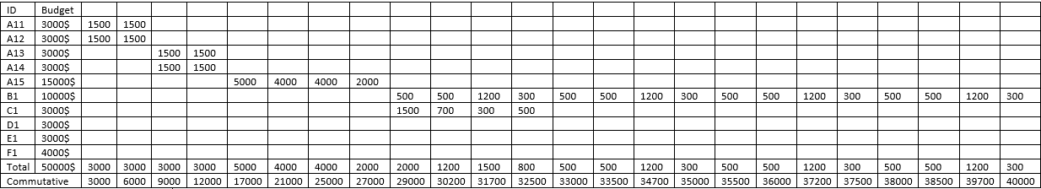

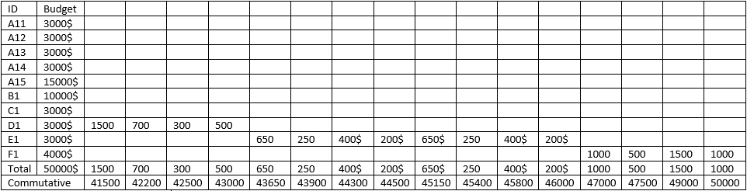

Risk Management:

Risk 1 Create the goals:

* The goals and ideas may be already existed.
* To avoid this danger, we will resort to assistants to search and check This leads to a delay in the time period.
* This risk will result in one to two days of delayed rendition.

Risk 2 specify requirements:

* Inability to specify requirements accurately.
* The technology would change and the specified requirements would be outdated.
* To avoid this danger, we could consult the network team in determining the technological requirements and making extensive research.

Risk 3 making work plan:

* Circumstances that make those responsible for certain tasks unable to perform these tasks, such as illness and death.
* To avoid this danger, we can make a pack up work plan or ask the Manager assistants to hire more than one person for a single task.
* If this risk occurs, it will lead to a delay in the implementation of tasks and an increase in the budget due to the use of new people to finish this task.

Risk 4 feasibility study & budget:

* The budget is not available at the time of project or it is not enough.
* To avoid this danger, the sponsor and feasibility team have to make sure that the budget is accurate and available before starting the project.
* If this risk occurs, this may lead to a delay in the implementation of the project and may lead to Failure to implement the project.

Risk 5 buying requirements:

* The required requirements do not exist locally and we will have to import them or it costs more than expected.
* To avoid this danger, the project management & project assistant have to search well in all local markets to purchase these requirements or choose the nearest foreign markets so that the project schedule is not affected and choosing the requirements that serve the purpose and fit the budget
* If this risk occurs, It may lead to delay the project schedule until the requirements are available and the budget is affected to purchase the required requirements.

Risk 6 Writing codes & testing the app:

* Errors occur while writing the code or the code does not serve the project's purpose correctly.
* To avoid this danger, the HR should make sure to choose good programmers.
* If this risk occurs, this may lead to a delay in the delivery of the code and an increase in cost due to the use of efficient programmers

Risk 7 make design and logo:

* Logo is similar to another application’s Logo or is not expressive, and the user interface may not be easy to use and complex.
* To avoid this danger, the marketing team & App developers should choose a unique logo and design smooth user interface.
* If this risk occurs, this leads to users not using the application and it will affect the work schedule until ensuring the integrity of the logo and interface.

Risk 8 property intellectual document:

* Stealing the project idea.
* To avoid this danger, the legal affairs should speed the completion of the process to protect the project from theft.
* If this risk occurs, this leads to the failure of the whole project.

team's members:

* اردينا اسعد امين.
* اسراء احمد عبد الغفور.
* اروى سيد ابراهيم.
* اروى محمد حمدى.

Group 1.

Section 2.